## Submitted by: Anushthan Saxena (S20210010027)

## Q1: Write a shell script to find the sum, the average and the product of the four integers

Script:

#! /bin/bash

a=10

b=20

c=30

d=40

sum=$(expr $a + $b + $c + $d)

product=$(expr $a \* $b \* $c \* $d)

average=$(expr $sum / 4)

echo "Variables: a = $a, b = $b, c = $c, d = $d"

echo "Sum = $sum"

echo "Product = $product"

echo "Average = $average"

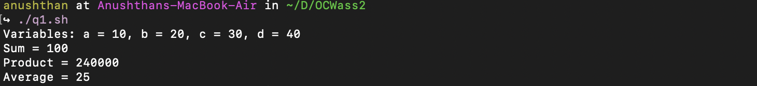

## Q2: Write a shell program to exchange the values of two variables.

Script:

#! /bin/bash

a=10

b=20

echo "Values before swapping: a = $a, b = $b"

temp=$a

a=$b

b=$temp

echo "Values after swapping: a = $a, b = $b"



## Q3: Find the lines containing a number in a file.

Script:

#! /bin/bash

touch sample

echo -e "123Sample\n0010027\nAssignment\n6questions" >> sample

grep [0-9] sample

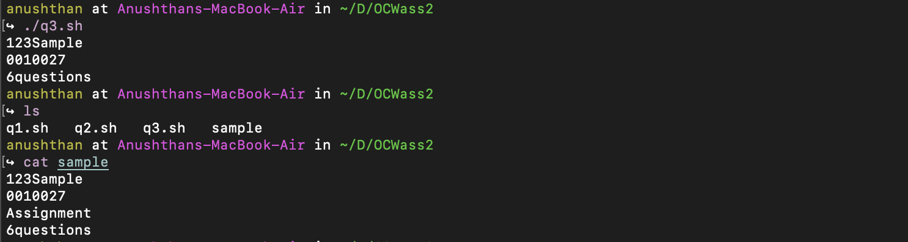

## Q4: Write a shell script to display the digits which are in odd position in a given 5-digit number

Script:

#! /bin/bash

num=12345

echo "Number given: $num"

for((i=1; i<=5; i+=2))

do

out=`echo $num | cut -c $i`

echo $out

done

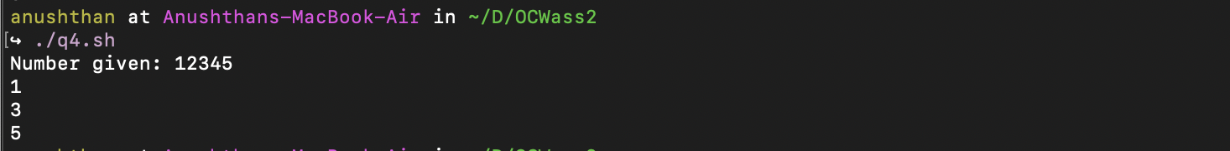

## Q5: Write a shell program to reverse the digits of 5-digit integer.

Script:

#! /bin/bash

num=123456

echo "Number given: $num"

ans=0

while [ $num -gt 0 ]

do

digit=$(expr $num % 10)

ans=$(expr $ans \* 10 + $digit)

num=$(expr $num / 10)

done

echo "Reversed number: $ans"



## Q6: Write a shell script to find the largest among the 3 given numbers.

Script:

#! /bin/bash

a=10

b=10

c=80

echo "Given numbers: a = $a, b = $b, c = $c"

if [ $a -gt $b ] && [ $a -gt $c ]

then

echo "Largest: $a"

elif [ $b -gt $a ] && [ $b -gt $c ]

then

echo "Largest: $b"

else

echo "Largest: $c"

fi

